Bug_01:
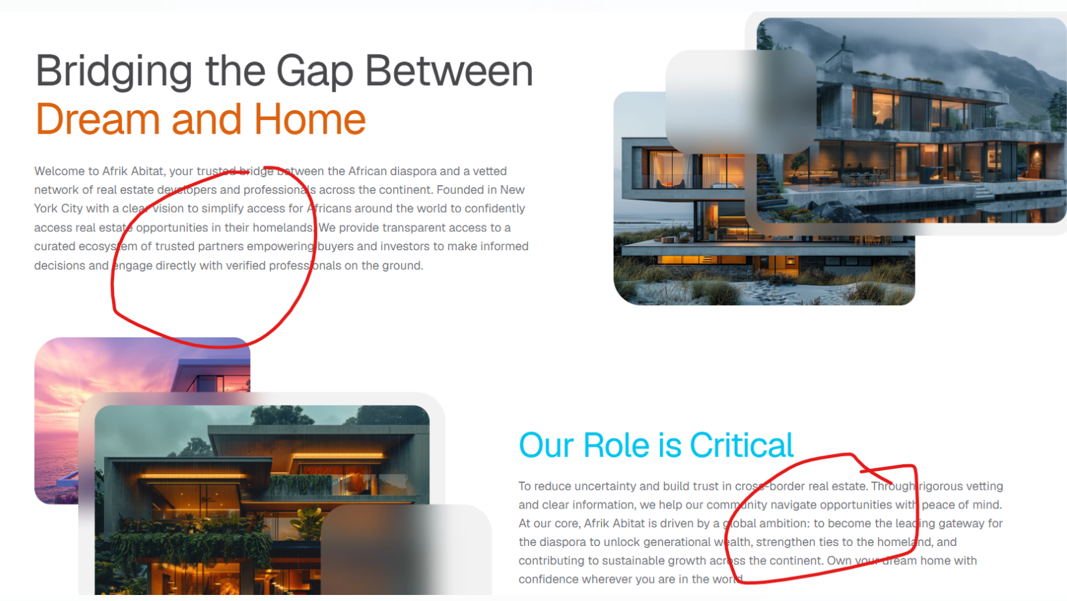
Increase the size of font
Bug_02:
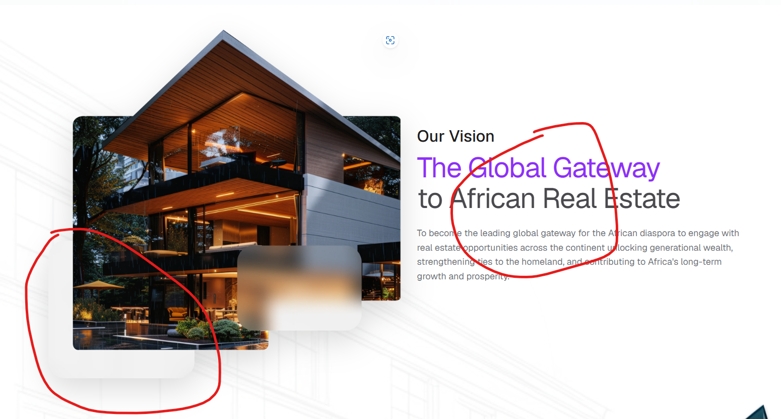
Increase the size of font and pic bottom card color and shadow issue

